**American International University-Bangladesh (AIUB)**  
**Department of Computer Science  
Faculty of Science & Technology (FST)  
Spring 21_22**

**Software Development Project Management**

**Faculty: Md. Anwarul Kabir**

**Section: C**

**Group No: 9**

|  |  |  |
| --- | --- | --- |
| **SN** | **Student Name** | **Student ID** |
| 1 | Mohammad Zaahirul Islam Faahim | 18-38163-2 |
| 2 | Shakhawat Hussain Shaon | 18-38227-2 |
| 3 | Tanvir Ahmed | 18-38323-2 |
| 4 | Rozina Akter | 18-38557-2 |

1. **Title:** Automated Dhaka Metro Rail Ticket System
2. **Introduction:**

The following Document is about the software development project for Dhaka Metro Rail Ticket Systems. This project is about an automated ticket issuing system that will sell tickets to the customers. Customers can buy their ticket themselves using cash or mobile banking or credit card. Customers will get a touch screen monitor where they will put their destination and book a ticket. While purchasing tickets customers will see their train info, arrival time, Cost of the ticket and other necessary information about the journey.

1. **Objectives:**

In our country, it is seen in the railway stations almost all the time, with long queues to buy tickets. In this way, the passengers have to suffer in various ways. Many times, long lines are created to buy tickets. As a result, gatherings are created in railway stations. Passengers lose a lot of important time due to crowds of people. If an automated ticket issuing system could be introduced, it would be beneficial to generate more tickets for customers. Customers could easily buy their tickets. The automated ticket issuing system is very convenient for the customer.

1. **Justification:**

The main reason for this problem is that there are more passengers than counters and irregularities in the distribution system. Lack of manpower is also a major problem. An automated ticket issuing system will save a lot of time and reduce the suffering of the customer. Customers can easily buy their tickets. There will be no delay in their journey. So it is very important to consider this issue. On the other hand, there are so many corrupt people who book tickets illegitimately and sell them at a high price. An automated ticketing system can solve this problem. Normally there are many passengers who traveling with fake tickets. As a result, the rights of the country are violated. Automated ticket issuing system is able to reduce this injustice.

1. **Stakeholders Analysis:**

* Primary stakeholders are people or entities that participate in direct economic transactions with an organization. Primary stakeholders are those that stand to be directly affected, either positively or negatively, by the project, decisions, or actions of the project. In Our Project primary stakeholders are employees & customers.
* Secondary stakeholders are people or entities that do not engage in direct economic transactions with the company and those are indirectly affected by the project, or decision, or actions of the project. In this project public, communities, activist groups, project support groups, and the media are second stakeholder.
* External stakeholders are groups outside a business or people who don't work inside the business but are affected in some way by the decisions and actions of the business. In Our Project external stakeholders are customers, suppliers, creditors, the local community, society, and the government.

1. **Feasibility Study:**

* Technical Feasibility: During this study, the analyst identifies the existing computer systems of the concerned department and determines whether these technical resources are sufficient for the proposed system or not. If they are not sufficient, the analyst suggests the configuration of the computer systems that are required. The analyst generally pursues two or three different configurations which satisfy the key technical requirements but which represent different costs. During technical feasibility study, financial resources and budget is also considered. The main objective of technical feasibility is to determine whether the project is technically feasible, provided it is economically feasible.
* Financial Feasibility: Financial feasibility is the most important study that determines the cost and benefits of the proposed system and compares with the budget. The cost of the project should not outweigh the budget. The cost of the project includes the cost of hardware, software, development and implementation. Cost/benefit analysis is the common method to determine the benefits that are expected from the proposed system and compare them with the costs expected to spend on development of the system. If benefits are found to be more than costs, then the analyst decides to continue the development of the proposed system otherwise considers it financially not feasible. The feasibility study presents both tangible and intangible benefits in a formal way.

1. **Systems Components:**

* **Train schedule and Ticket price**

**Functional Requirement:**

* User will see different type of events in the system which are,
* Train schedule.
* Train ticket price.

Priority Level: Medium.  
Precondition: Not required.

Cross platform: 8.

* **Booking Ticket**

**Functional Requirement:**

* User will have to book their tickets at least 5 minutes before the train arrives.
* User will have to submit their phone number.
* User will have to submit a travel date and time.
* User will have to set his destination.
* User will have to confirm their ticket by pressing submit.

Priority Level: High  
Precondition: User must have a phone number.

* **Payment**

**Functional Requirement:**

* Users (who will receive the service) will be able to pay in cash.
* User will be able to pay in mobile banking by scanning QR code.
* User (who will receive the service) will be able to pay in card.

Priority Level: High.  
Precondition: User must have a phone number, cash or any kind of banking system.

Cross platform: 2.

* **Ticket confirmation**

**Functional Requirement:**

* Users are able to confirm their ticket.

Priority Level: Medium  
Precondition: User must have a phone number and confirm payment.

Cross platform: 2, 3.

* **Ticket cancellation**

**Functional Requirement:**

* User will have to cancel his or her ticket at least 5 minutes before the train arrives.
* User will have to verify his or her phone number by submitting an OTP (One-time password).
* The user will have to submit his train name, train date and time.

Priority Level: High.  
Precondition: User must have a phone number which is used to book the ticket.

Cross platform: 4, 8.

* **Search**

**Functional Requirement:**

* User shall be able to search train schedules using search function.
* User shall be able to search ticket price using search function.

Priority Level: High.  
Precondition: Not required.

* **About and Contacts**

**Functional Requirement:**

* User will see about the system.
* User will see our email and phone number to contact us.

Priority Level: Low  
Precondition: Not required.

* **Admin**

**Functional Requirement:**

* Admin can maintain the train schedule.
* Admin can maintain the ticket price.
* Admin can add another admin.
* Admin can see the payment invoice.
* Admin can see customer details.
* Admin can confirm ticket cancellation.

Priority Level: High  
Precondition: Admin have valid user id and password

1. **Effort Estimation:**

An estimation of each task using COCOMO model is given below-

Organic -Software projects are said to be organic if the required team size is small enough, the problem is well-understood and has already been solved, and team members have just a minimal amount of prior knowledge about the issue at hand.

Since this is an organic system, the value of coefficient (c) is 2.4, project complexity (p) is 1.05, size (KLOC) is 9, T is 0.38

1. Effort= PM = c * (size) P

= 2.4 *(9) 1.05

= 24.10 person-month

2. Development Time= DM = 2.50 * (Effort) T

= 2.50 * (24.10) 0.38

= 8.37 Months

~ 36 Weeks

3. Required number of people = ST = Effort / DM

= 24.10 / 8.37

= 2.87 ~ 3 Persons

1. **Work Break Down Structure:**

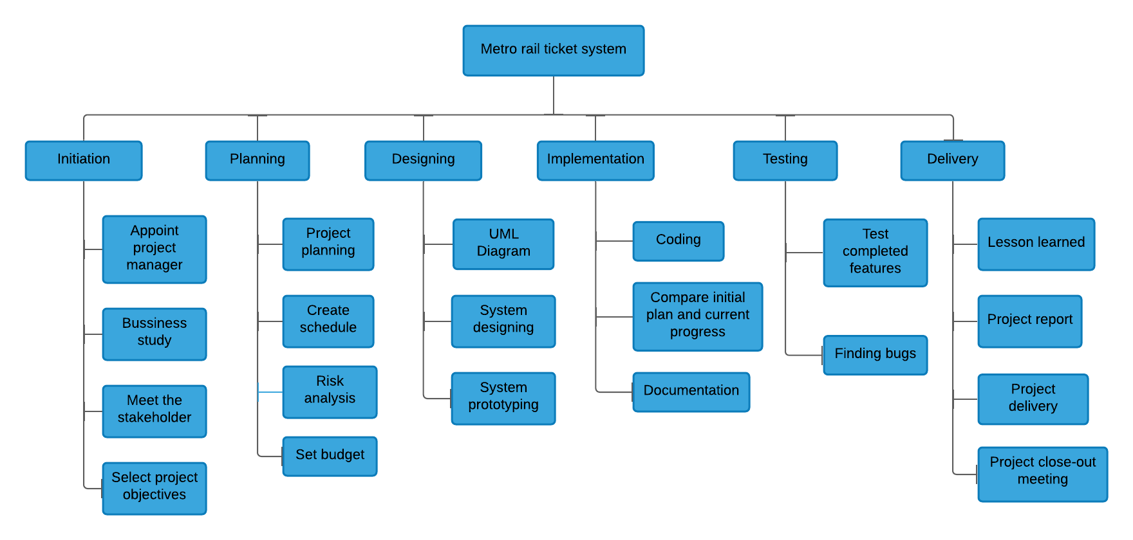

1. **Activity Diagram:**

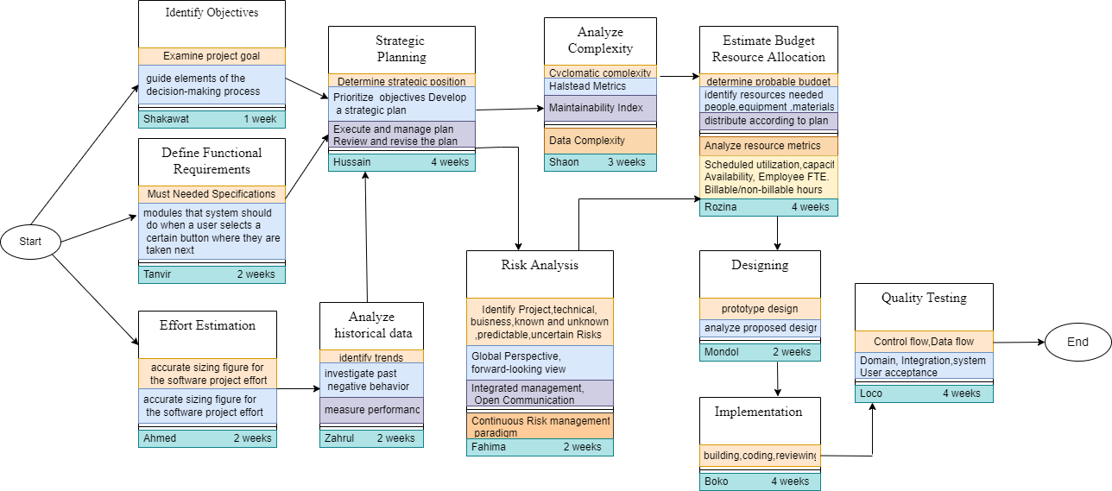

## Scheduling the Tasks:

|  |  |  |
| --- | --- | --- |
| **Tasks** | **Task Duration (Weeks)** | **Predecessor** |
| 1. Feasibility Study | 1 | - |
| 2. Defining Business Objectives | 1 | 1 |
| 3. Defining Requirements | 2 | 1,2 |
| 4. Effort Estimation | 3 | 1,2 |
| 5. Strategic Planning | 4 | 3,4 |
| 6. Analyzing Historical Data | 2 | 5 |
| 7. Analyzing Complexity | 3 | 6 |
| 8. Analyzing All Risks | 2 | 6 |
| 9. Budget Estimation | 2 | 4,8 |
| 10. Allocating Resource | 2 | 5,9 |
| 11. Prototyping | 2 | 3.,10 |
| 12. Coding | 4 | 7,11 |
| 13. Software Testing | 4 | 12 |
| 14. Installation | 1 | 12,13 |
| 15. Client Training and Delivery | 2 | 14 |

## Risk Analysis:

|  |  |  |  |  |
| --- | --- | --- | --- | --- |
| S/N | Risk Description | Probability | Impact | Mitigation Plan |
| 1 | Unrealistic time estimate | 40% | High | Take multiple estimations. |
| 2 | Loss of work due to equipment failure/loss | 30% | High | Weekly data backup to Hard drive. |
| 3 | Unavailability of API’s | 20% | Medium | Alternative API’s will be checked for. |
| 4 | Developers needs to hardware or software requirements | 5% | Medium | Select the best available hardware or software components. |
| 5 | Exceeding budget | 15% | Medium | Some extra budget needs to be added. |
| 6 | Testing and debugging error | 10% | Medium | Adopting qualitative testers. |
| 7 | Failure of server | 10% | Low | Backup system database regularly. |
| 8 | Staff/Personnel shortfall | 5% | Low | Take some extra members in the team. |

1. **Conclusion:**

This automated system is very useful for being on the path of developing and digitized country. It is very useful for the work of metro rail in Bangladesh. Automated tickets do not require many employees, 24 hours will be given in less time, which is not expensive and time consuming. No one will be able to sell tickets in black because of the automated ticket system. This solution is particularly appropriate to solve the problem because no need to hire employees and maintenance costs are low. Will be able to provide 24 hours service and there will be no corruption. The solution is feasible to meet the business objective.